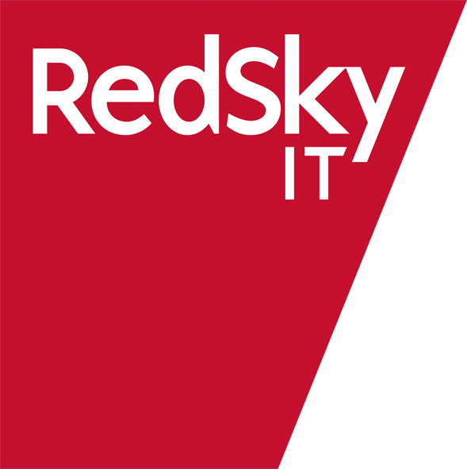

RedSky IT Proposal

To

Tesco US

For the implementation of

Tesco Technical Library in the United States

Issued: 3rd August 2006
Version: 1
Ref: Creations/Tesco US/030806v1
Author: Paul Woodward
Title: Sales & Marketing Director

Content:

Executive Summary 2
RedSky IT Company Profile 4
The Tesco US Enhancements 6
Hardware, OS, Databases, Support, Hosted Services 7
Cost Profile 10

The information contained in this Proposal or any part thereof, including its Exhibits, Schedules, and other documents and instruments delivered or to be delivered to Company, is true, accurate, and complete. This Proposal includes all information necessary to ensure that the statements therein do not in whole or in part mislead the Company as to any material fact.

Executive Summary

We are please to provide this proposal for the implementation of the Tesco Technical Library in the Unites States.

This proposal outlines the modules, services, development requirements and annual charges estimated to fully implement the solution across Tesco US and their supply chain for the lifecycle management their own label products enabling:

- Due diligence and product safety
- Full product and supplier data management
- Real time visibility and control
- Supply chain collaboration
- ‘Right first time’ approach
- Faster speed to market of new and re-developed products

The Tesco Technical Library is currently used by over 1700 sites across Europe supplying own label products into Tesco Stores in the UK. The Technical Library has been designed and developed in partnership with Tesco and currently offers their supply chain:

- Online collaborative specification management
- Online pack copy management
- Online policy and document library
- Online news
- Online Alerts
- Management Reporting
- Query Management

The Technical Library will over the next 6 months also offer online Audits and Visits, Product Surveillance and Scorecards.

Our Proposal
The proposal is based upon the stated requirement for a cloned UK solution customised for the US market fully hosted and supported by RedSky IT.

The elements of the proposal are:

- Licence
During 2005 Tesco UK committed to an international global licence agreement of £100,000 ($187,000 based upon today’s exchange rate of $1.87 to the pound) of which 50% of this has been paid to secure the price with the remainder due upon adoption by any international division.

- Services
40 days of professional consultancy, training and project management services have been identified for the implementation in the US. Due to the initial timescales UK skilled resources will be used during the implementation.

- Development
56.5 days of development activity has been identified to meet the requirements detailed by Tesco US. Due to the initial timescales additional resource has been recruited and therefore a premium rate has been applied to cover these short term costs.

- Hardware and Annual Hosting Fees
The proposal is based upon RedSky IT providing all hardware, hosting and support services as required by Tesco US. This also achieves several cost benefits by utilising existing supporting hardware and shared hosting services with the UK.

- Annual Support
The annual support fees have been based upon <100 Tesco users and <100 supplier sites supported across the 3 time zones in the US.

- Project Funding
Based upon <100 users we have estimated an annual project funding pot based upon standard UK rates. The proposal also includes an optional RedSky IT Supplier registration and communication program for marketing and collecting these fees.

In summary the initial implementation fee for the Tesco Technical Library in the US delivering the above benefits and features in year 1 is £277,607.50 ($519,126.03) with an annual fee of £133,407.50 ($249,472.03) in years 2 and beyond over a 5 year contract.

RedSky IT US Operations
As discussed, RedSky IT are currently setting up a US operation for the Retail business. This is based in South Plainfield, New Jersey. Over the next 18 months is planned for this location to offer all services to cover the sales process, implementations and annual support for the US.

Project Timescales
This proposal is based upon a 6 week development program of the Tesco Technical Library application for the US. Based upon an order week commencing 7th August 2006 it is estimated that IAT and Tesco UAT could begin mid September with Training during October. Supplier marketing and registration can be ran in parallel to the UAT and training and therefore go live could be achieved for the end of October. A full project plan needs to be discussed with you and the team.

Closing Statement

RedSky IT would like the opportunity to work with Tesco US to achieve the benefits highlighted in the document that the implementation of the Tesco Technical Library will deliver. We believe our proven, award winning, best practice approach to our software development, implementation practices and supply chain management and our partnership with Tesco in the UK provides the reassurance of working with the most experienced provider.

I hope that this proposal meets your requirements and I look forward to discussing the content with you on Friday 4th at 5pm BST.

Kind regards

Paul Woodward
Sales and Marketing Director
RedSky IT

1 Cragwood Road, Suite # 202
South Plainfield
NJ 07080

Direct: 001 908 941 1290
Fax: 001 831 603 7850

Mobile: +44 (0) 7778 969872

RedSky IT Company Profile

RedSky IT has over 25 years experience in the IT market and is recognised as one of the UK’s leading IT solution and services providers. We develop award winning market specific software applications and provide the infrastructure and services to support them.

- Highly Skilled and Accredited. RedSky IT are ISO 9001 and TickIT accredited. In conjunction with Asda, RedSky IT won the Best Use of IT in Retail 2004 and with Safeway, RedSky IT won the coveted UK National Business Award 2003/04 for the Supply Chain Strategy of the Year. RedSky IT hold three Microsoft Gold Partner awards and was the first company in the world to achieve this level of accreditation. We are an IBM Premier Partner, and have deployed hundreds of successful Lotus implementations. Furthermore, we have won several prestigious awards including the Computer Weekly e-Business Excellence Award and the Microsoft Partner Win of the Year 2001.

- Breadth of service. RedSky IT are able to provide a solution to all aspects of the project at Tesco and therefore minimise risk. The services that will be provided range from industry expertise and IT implementation right through to supporting large scale web solutions.

- Experience. RedSky IT have been implementing retail solutions of a similar nature for over ten years. We pride ourselves on delivering projects that exceed our Customer’s expectations. The experience that we have gained during such projects means that we are aware of the change management and operational factors that surround such an implementation and are able to avoid many of the issues that could occur.

- Company size. We are a stable, credible £30m organisation large enough to provide a high quality service to Tesco and a truly flexible, responsive and customer focused approach to our implementations.

- Future capability. We believe that Tesco are looking to build a long-term partnership with an organisation that can not only satisfy the objectives of this project but can work with the Technical and Product Development teams on future projects. RedSky IT employ over 350 skilled industry and IT professionals with an annual R&D investment in Creations in excess £1 million.
- Best of Breed
Creations (branded Tesco Technical Library for Tesco) is the most widely used product lifecycle system in the UK with over 2,300 companies collaboratively developing product and specifications daily. To enable this growing joint community of retailers and suppliers to work together considerable development and investment has gone into creating data and connectivity standards, shared knowledge and experiences and future evolvement and industry initiative programs.

RedSky IT are currently leading several industry initiatives in collaboration with The Provisions Trade Federation, Institute of Grocery Distribution and Bodycote Laboratories.
- Experience
Creations retail customers include: ASDA Wal*Mart, Tesco, J Sainsbury, Somerfield, Iceland, Woodwards, Waitrose, Booker Cash and Carry and The Body Shop International. Creations provides these organisations with real time visibility and management of over 27,000 own brand products, category planning, product specifications, artwork and label design, vendor performance, supply chain audits and complete due diligence quality protection through collaboration with over 17,000 users.
- Brand Protection
The introduction of a collaborative supply chain portal opens the channels for a single source of data which improves accuracy, visibility and speed to market. The ability to run supply chain enquiries, data validation and analysis with improved communication ensures a quick and accurate response to market changes, concerns, incidents, product withdrawals and customer enquiries.
- Growth
Accelerated market growth is achieved through Creations by the unique integration of the whole process. This ensures data is entered once, significantly reducing duplication and administration from the critical path ensuring a faster route to market, quicker returns on investment, repeatable high quality standards and further time for innovation and development.

‘1 retailer has reduced product lead times by up to 10 weeks increasing sales revenue by c.£6m. Another recorded a 50% reduction in their product specification process which equated to a reduction in time to market by 3 weeks’
- Success Rate
The combination of a structured central process, collaboration and the visibility of all stages within the product lifecycle allows for better informed decisions and controls to be implemented, improving communication, planning and product assessment and increasing the success ratio of new products to market.

The Tesco US Enhancements

Please refer to the attached document: USA Specification Requirements, Ref: 432.

Hardware, OS, Databases, Support, Hosted Services

Overview
The solution resides on an intel based server running MS Windows 2003 server and Lotus Domino R6.5 which is used as both application server and database server. A typical installation would be a primary server clustered with a backup for resilience purposes. This could be swapped out in the event of a primary server failure. A third server is designated as a reporting server also running Lotus Domino R6.5

Hardware
The following server specification is required to support this solution.

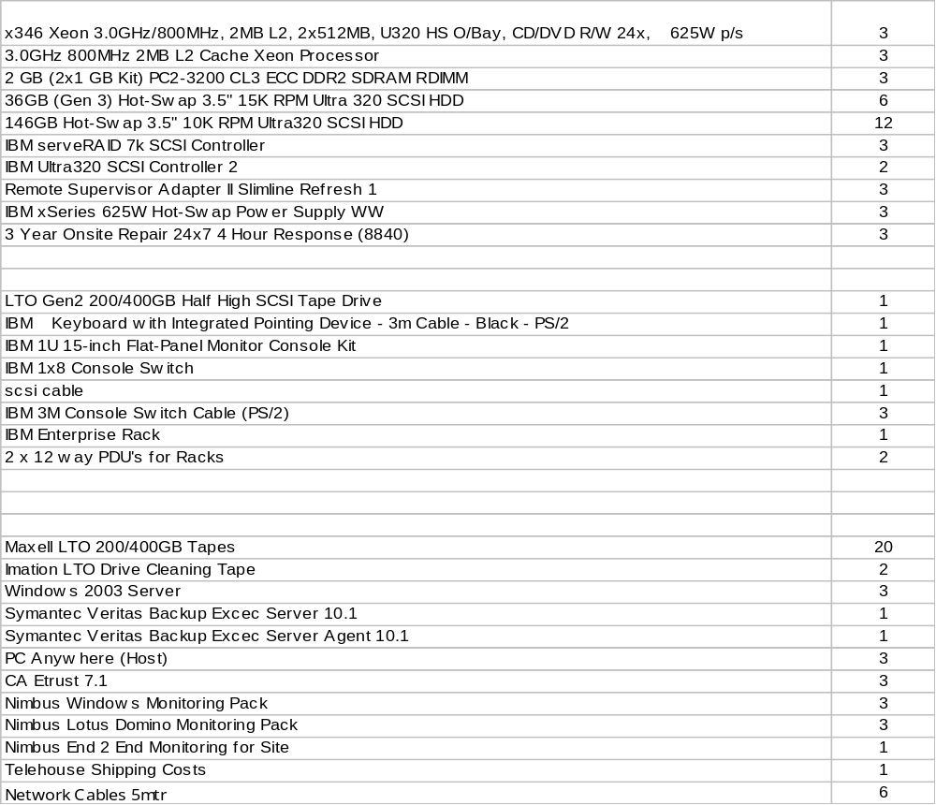

Performance & Usage Figures
This very much depends on the frequency of use however for a similar sized retailer the service would accommodate in excess of 200 concurrent users. Initial data estimate would be 20-30Gb in the first year rising by 10Gb each subsequent year. These figures are obviously subject to numerous factors and so should only be taken as a guide.

The performance of the solution can be impacted in any number of ways outside of the control of RedSky IT such as corporate infrastructure, Lan traffic, Internet usage, Users PC, Firewalls, Proxy servers etc. For this reason timings cannot be given however demonstration of the solution of specific networks can be arranged.

Problems and Enhancements
All enhancements are considered as part of the core development and evolvement of Creations. Future releases of the core application are covered by the Annual Application Licence and Maintenance Fee.
RedSky IT provide and existing service delivery and service support function for the majority of the UK food and retail market. This function is resourced/skilled to the appropriate levels and operates within best practice guidelines. The 24x7 Service Support function utilizes a 3 shift replication delivering the following ITIL based functions:
- Call Handling – The initial receipt and classification of events.
- Incident Management – The process of restoring the service to the user.
- Problem Management – The process of root cause analysis to remove/negate incidents.
- Change Management/Work Request – The controlled delivery of service changes and additions.
- Release Management - The controlled release of changes to the live environment.
Service Level Agreements are constructed to monitor the following service components:
- Incidents Management
- Problem Management
- Change Management
- Release Management
- Work Request Management
An example SLA is as follows:

Event Category | Priority | Problem description | Classification / example | Response time (hrs) | Target Fix time
1 | Critical | Main System failure / Down | Global access failure to main system ( RedSky or Managed Service software application / database failure / server failure) | 30 minutes | 4 Business hours
2 | High Impact | Process / Operator queries | Advice & guidance | 2 hours | 2 working days
3 | High Impact | Major component failure. | Function failure affecting global operators i.e. brand protection / document library / specifications / system automated e-mails. | 4 hours | 3 working days
4 | Medium Impact | Partial software failure. | Software / data error / bug that does not prevent operator from completing process. | 6 hours | 15 working days
5 | Low Impact | Cosmetic change / minor or low impact issue | Minor problem with little or no impact, including single transaction type failure. | 8 hours | 90 working days

Backup, Recovery and Data Integrity
The solution is designed to be constantly with interruptions only occurring at scheduled upgrade / patch release times.

Backups are performed from the backup server and so not effecting the live site.

Partial data restores can be applied to the system for major functional areas. Other partial restores would have to be considered depending on system implications.

Although the system cannot technically by rolled back for incomplete transactions it has been designed to illuminate the need for communications failures.

Security
Lotus Domino handles all the security within the system and is based around the premise of protecting resources. The resource or objects that are being protected are setup to define the rights of users to access and change the object. Information about access rights and privileges are stored with each protected resource. These are assigned using groups and roles.

This method gives the flexibility of securing and part of the system from field to function of form. As an example a specification can travel through its approval cycle and be locked from editing or viewing by different roles as it progresses.

Users can be added or removed from groups as required and the access these groups give can be changed to suit a customers requirements.

Authentication to the solution is via username and password and all communications between client and server are over HTTPS.

Data entered via an integrated system can be kept secure in a number of ways. An appropriate level of validation is performed on the data to ensure its integrity and validity. Generally integration with other solutions is achieved on specific requests and so a secure solution would be proposed and agreed by both parties before proceeding. However methods currently include secure web service links using XML and soap.
Hosting and Managed Service

RedSky IT will provide the managed service in line with our standard Agreements. In summary this includes the following:

Secure Web Hosting
All hardware and communications equipment is located in our secure air conditioned data centre located at Telehouse, London.
Live and test servers are installed behind industry standard firewalls.
Our web hosting service has been duplicated allowing full resilience minimising service failures.

Multi-environment support
Four active environments will be maintained:
Live environment at London;
Test environment at Nottingham - for system testing, UAT (User Acceptance Test) and impact assessments;
Training environment; and
Development environment at Nottingham for enhancements and error corrections.

Pro-active Health Checks
Periodic health checks carried out on the main points of the system operation and functions. These are usually run on twice daily, weekly and monthly schedules.
Real-time health checks responding to automatic site monitoring with SMS messaging alerts.

Re-active Support based on service levels
Severity levels ensure CRITICAL issues are dealt with promptly as the highest priority.
Response times and escalation management are dependent on severity levels e.g. with Severity Level 1 response time immediate (10 minutes).
A contact co-ordinator continually monitors issue logs and response times and stays in contact with TESCO allowing our technical teams to focus on problem resolution.
Call closure is in consultation with TESCO.

Web Portal administration
Issuing and maintaining user ID and Pass codes.
Assisting with Supplier communication.
Liaison with other third parties e.g. Recipe Management System providers.

Cost Profile

The below table details a 5 year contract and funding model based upon the proposed solution within this document and today’s exchange rate of $1.87.
